Land & Water use FRQs
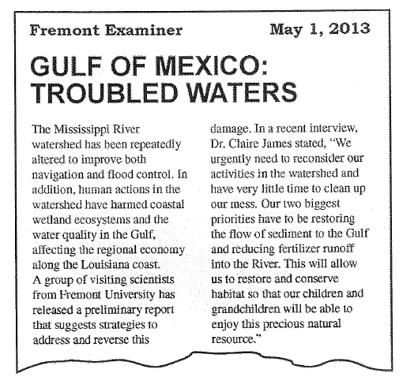

1. (a) Identify TWO human activities that alter the natural flow of sediments into Gulf Coast ecosystems. Explain how each of the activities alters the flow of sediments.

(b) Dr. James says that it is important to restore sediments. Describe TWO ways that the loss of natural sediment harms Gulf Coast wetland ecosystems.

(c) Dr. James also indicates that it is necessary to limit fertilizer runoff into the Mississippi River.
(i) Describe TWO environmental impacts on the marine ecosystem that are caused by fertilizer when it flows into the Gulf of Mexico.
(ii)What are TWO economic consequences that result from the flow of fertilizer into the Gulf of Mexico?
(d) Describe ONE strategy, other than reducing the use of fertilizer, that can be employed to reduce the flow of nutrients into the Mississippi River.

2. (Partial FRQ)
(a) Describe TWO practical measures that a family could take that would reduce their overall water use at home.

(b) Describe TWO conservation measures (other than reducing hot water use) that a family could take to reduce the total amount of energy that they use at home.

3. The Colorado River flows from the Colorado Rockies to the Gulf of California. The primary source of Colorado River water is melting Rocky Mountain snowpack. Once the river descends from the Rockies, it flows through a landscape that is dominated by desert. Colorado River water carries a high load of sediment.

(a) Multiple dams have been erected along the Colorado River. Identify TWO benefits other than agriculture and recreation that people derive from that system of dams. .

(b) Discuss TWO potential environmental consequences of damming a major river.

(c) Competition for access to Colorado River water has increased dramatically due to increased population size and intensive agricultural use. Describe TWO conservation strategies for reducing agricultural water consumption.

(d) Identify TWO possible environmental consequences of climate change on the hydrology of the Colorado River system.
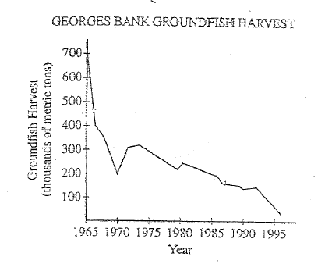

4. The graph above shows the decline in the catch of groundfish (such as cod, haddock, and flounder) from Georges Bank from 1965 to l995. This decline in the fish harvest resulted in the closure of large portions of the fishery.

(a) Identify the five-year period during which the greatest rate of decline in the fish harvest ook place. For that five-year period, calculate the rate of decline in the fish harvest, in metric tons per year. Show clearly how you determined your answer.

(b) Choose any TWO commercial fishing practices from the list below. For each of your choices, describe the practice and explain the role it plays in the depletion of marine organisms:
Bottom trawling
Long-line fishing
Using drift nets/gi1l nets/purse seines
Using sonar

(c) Identify one international regulation or United States federal law that applies to the harvesting of marine food resources and explain how that regulation or law11elps to manage marine species.

(d) The oceans of the world are often referred to as a commons. Give an example of one other such commons, explain how human activities affect that commons, and suggest one practical method for managing that commons.

5. For decades, forest fires in the United States have been suppressed. In 2003 legislation was passed under the Healthy Forests Initiative (HFI) in response to the record-breaking wildfires that had occurred in the early 2000s. Some environmental and conservation groups fear that negative impact could result if timber companies are encouraged to harvest medium- and large-size trees in federally owned forests while clearing away the smaller trees and underbrush.

- Identify TWO characteristics of forests that develop when fires are suppressed, and explain why the practice of fire suppression does not reduce, but actually increases, the risk of intense and extensive forest fires.

- The effects of the HFI are expected to extend beyond fire reduction. Excluding fire reduction, describe ONE positive and ONE negative effect likely to result from the implementation of the provisions of the HFL

- Describe TWO ecosystem services provided for humans by forests. Explain how clear-cutting would affect each ecosystem service you describe. ·
- Identify a specific type of plant community or biome (other than a forest) that is naturally maintained by fire. Explain how the fire maintains the community or biome.

6. Most of the coal mined in the United States today comes from surface (strip) mines: In surface mining, the vegetation, soil, and rock covering the coal (referred to as overburden) are removed and set aside. After the coal has been hauled away, good conservation practices ·require that the overburden be replaced and the surface be restored to its original condition. Land restoration may be difficult in some regions, due to factors such as the local climate, the thickness of the coal seam, the extent of the overburden, and the sulfur content of the coal.

- Describe the steps that should be taken to restore the land after the overburden has been replaced.

- Explain why the restoration of the land would likely be more difficult in an arid climate (less than ten inches of precipitation per year).

- Describe one environmental impact that the sulfur content of the remaining coal and the tailings would have on the reclamation process and suggest a possible remedy.

- Other than mining and reclamation, describe TWO environmental impacts of using coal for energy.

- Explain why per capita coal consumption in the United States is likely to increase.

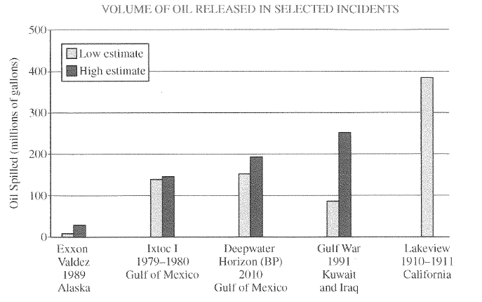

7. Oil spills can be devastating in scope and damage. Since 1900, there have been many oil spills around the world that have had significant ecological and economic impacts.
  - Using the data in the graph above, determine the maximum volume of oil estimated to have been spilled during the Deepwater Horizon (BP) incident.
  - Describe TWO environmental problems that can result from oil spills in coastal areas.
(c) Identify one economic impact that results from oil spills in coastal areas.
  - Chemical dispersants have been used in cleanup efforts following major oil spills.
    - Discuss both one advantage and one disadvantage of the use of chemical dispersants for oil spill cleanup.
    - Identify either one biological or one physical method (other than chemical dispersal) used for oil spill cleanup in coastal waters or on beaches and how the method is used.

